Team ID-PNT2022TMID16365

Project ID-A Novel Method for Handwritten Digit Recognition System

# Bhavadharani M

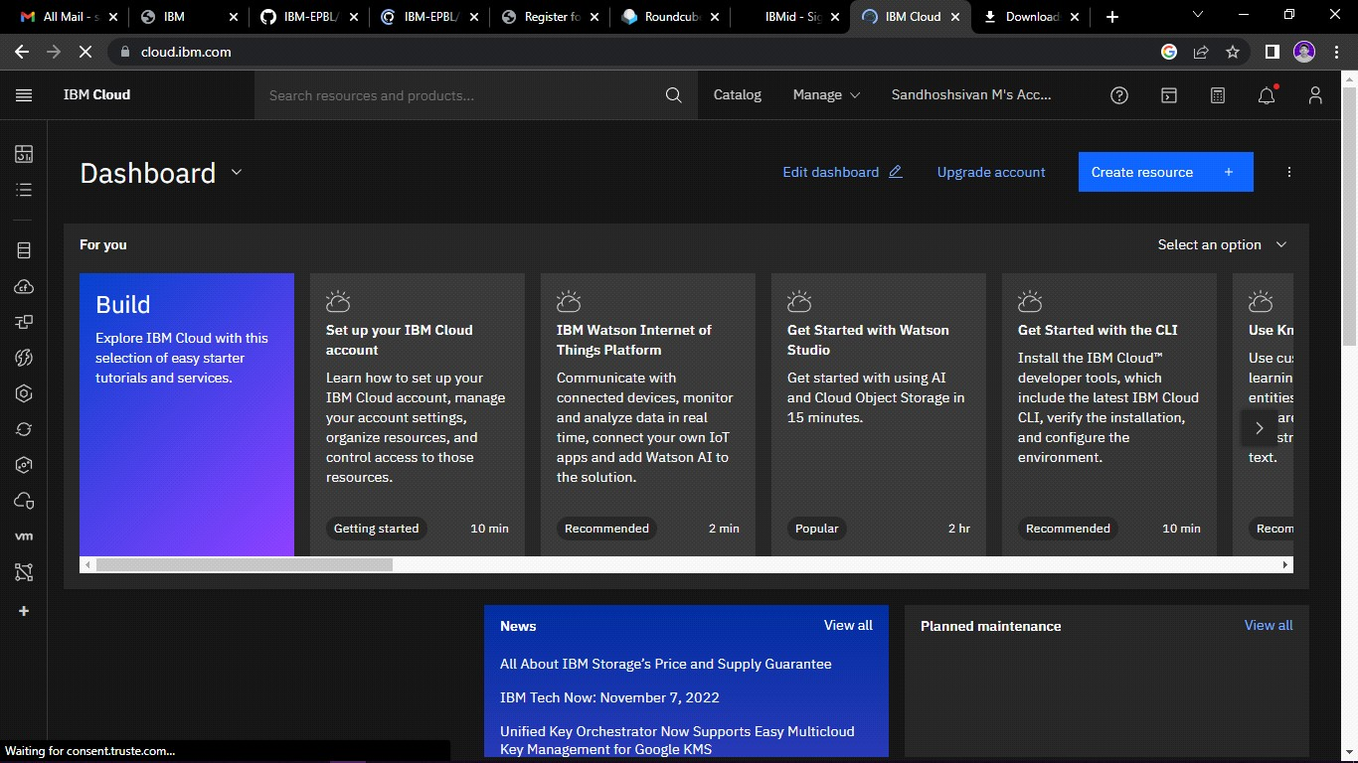

Sowmiya P

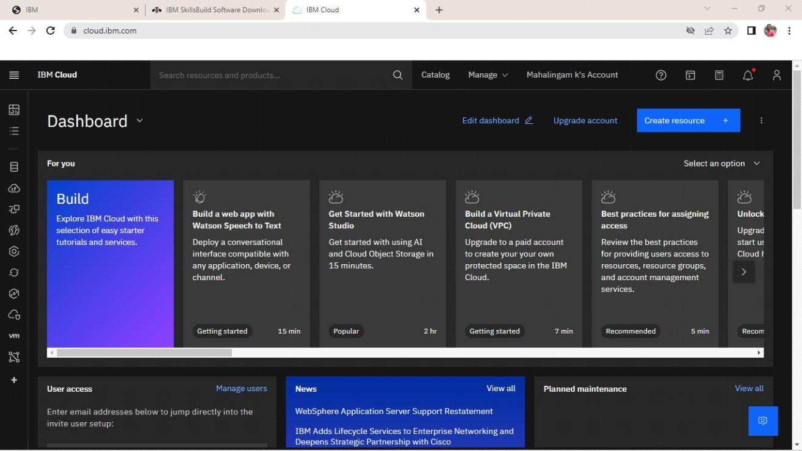

Shakthi Bharathi R

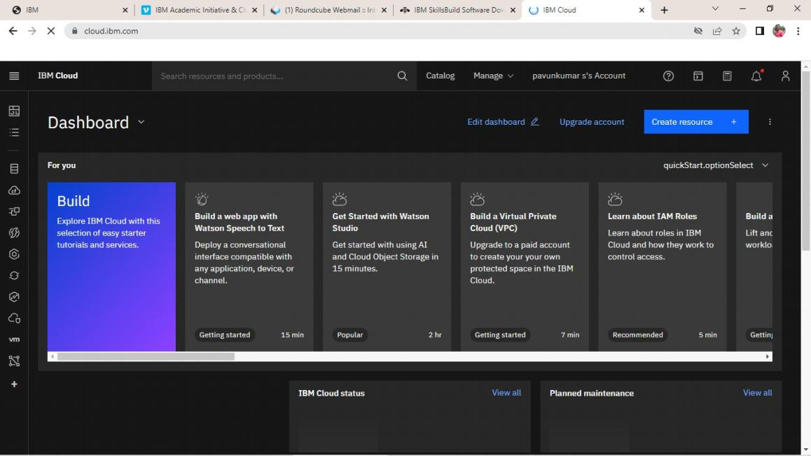

Kaviya

